**All About** [**GitHub**](https://en.wikipedia.org/wiki/GitHub#:~:text=The%20GitHub%20service%20was%20developed,is%20located%20in%20San%20Francisco.)

First Steps:

1. Watch this Introduction Video: <https://www.youtube.com/watch?v=PQsJR8ci3J0&ab_channel=edureka%21>
2. Get a GitHub Account: <https://github.com/>

On this page, select “Sign Up” and create your account

1. Download and Install GitHub Desktop on your computer

Go to: <https://desktop.github.com/>

Choose the program for your computer system.

Also on this page, if you click on “Help”, you will be able to access all of

the related documentation.

Why use GitHub?

1. It’s free !!!
2. It allows you to access/share “non-confidential” files easily since it is cloud-based.
3. Enables collaboration between users.
4. Projects/Repository can be “Private” or “Public”
5. Each repository has approximately 5GB of space (optimally 1 GB).
6. Programming is minimal.
7. It is a “Version Control System”

Now, what exactly is [GitHub](https://en.wikipedia.org/wiki/GitHub#:~:text=The%20GitHub%20service%20was%20developed,is%20located%20in%20San%20Francisco.)? [[Images](https://octodex.github.com/)]

Think of a filing cabinet, with three drawers, one is locked and the other two not.

In each drawer, there are folders and each folder has a label.

Folders can contain documents, photos, and other “stuff”

Now equate your GitHub account to the cabinet, and your repositories to the drawers. The locked drawer is a “Private” repository and the open ones are “Public”. You can have multiple accounts hence more than one cabinet.



**So this is GitHub !**

 **It’s a virtual Filing System for different types of Information**

**It’s about collaboration with ease of access**



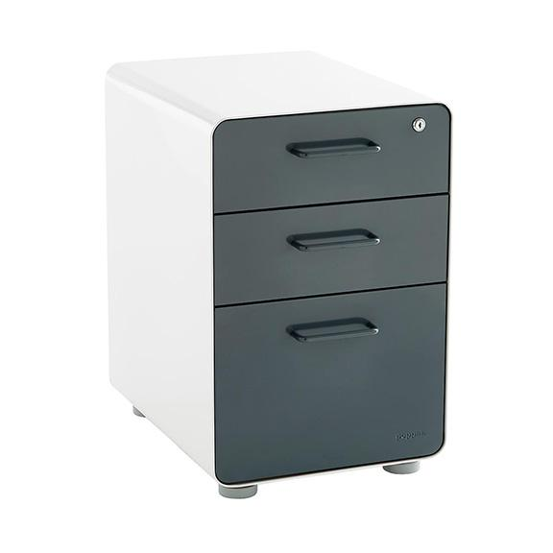 **It’s about Privacy with Freedom**